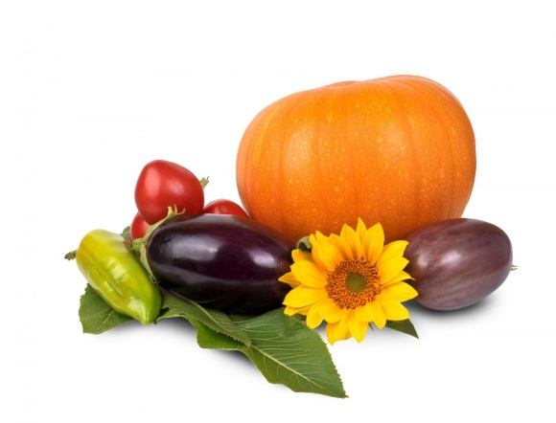

Come and join the celebrations

Harvest Thanksgiving

Saturday September 23rd
10.30 a.m.
Children and their families breakfast worship with activities preparing for Harvest Festival, in the Old Hall

Sunday September 24th
10.00 a.m
Harvest Festival Eucharist at 10 a.m., followed by harvest breakfast in the Old Hall

